Penson’s Sendero Environment

Sendero comprises four windows services, a client desktop application, and Penson’s Clientsite. The Clientsite web application connects to Sender using Port 8822. This port will need to be opened to allow communication if the firewall sits between the services and the Clientsite.
Release 1.2 requires IBM’s MQ Client in order to run. This must be installed before the Loanet service is installed. Use the standard\normal settings when installing this program.

General IBM MQ Client Information
The MQ Client is used by the Loanet window’s service and must be installed before the service is installed and started. The install package is located under the root Sendero directory in the IBM folder. Double click the icon to execute the package. Agree to the licensing agreements and when prompted select: “Typical” for the “Setup Type” (see diagram below). Once the setup has completed you can begin to install the Anetics services for Sendero.

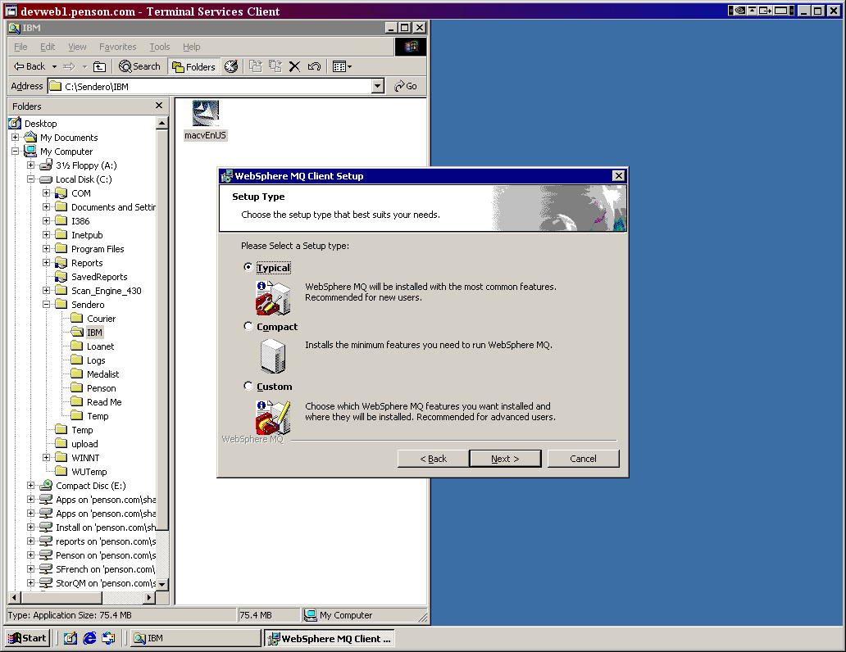

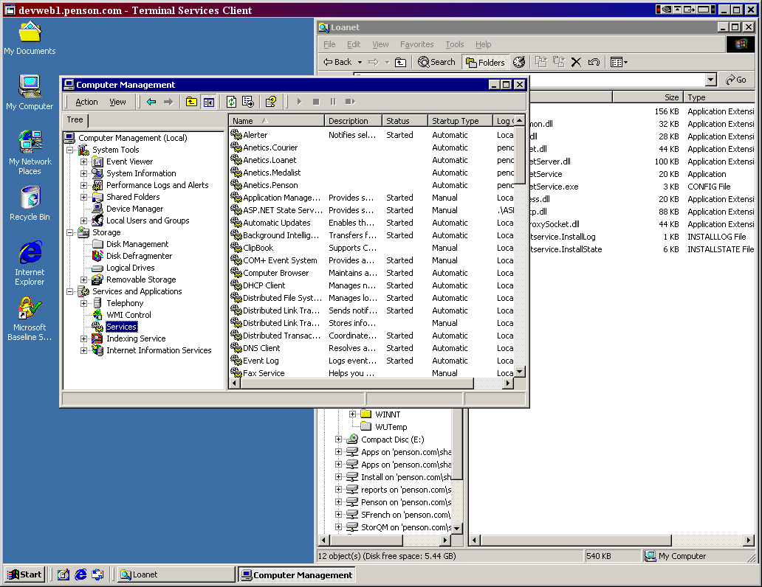

Staging
Web Servers running IIS: STGDMZ001 (192.168.10.22), STGDMZ002
Sendero Server: RSPEN001 (172.30.2.43)

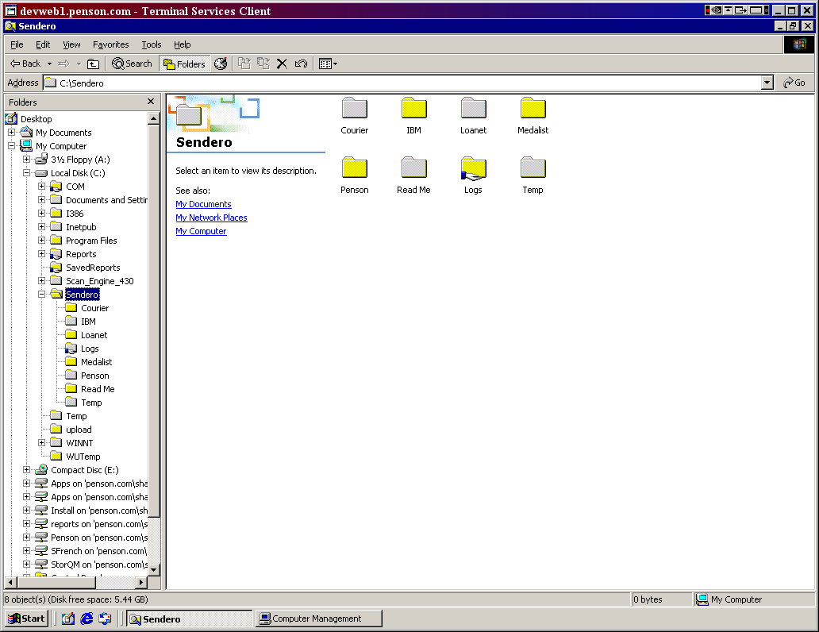

- Logon to the server and create a folder call Sendero under the root directory on the C: drive.
- See diagram above for the contents of the folder. Create these folders and copy the files listed below to them.
  - Courier: Contains the Courier service that loads all threshold data and inventory from subscriptions. It contains the following files:
    - Anetics.Common.dll
    - Anetics.Courier.dll
    - Anetics.CourierService.exe
    - Anetics.CourierService.exe.config
    - Anetics.Filer.dll
    - Rebex.Net.Ftp.dll
    - Rebex.Net.ProxySocket.dll
  - Medalist: Contains the Medalist service that will set the business dates. It contains the following files:
    - Anetics.Common.dll
    - Anetics.Filer.dll
    - Anetics.Medalist.dll
    - Anetics.MedalistServer.dll
    - Anetics.MedalistService.exe
    - Anetics.MedalistService.exe.config
    - Anetics.Process.dll
    - Anetics.Services.dll
    - Rebex.Net.Ftp.dll
    - Rebex.Net.ProxySocket.dll
  - Penson: Contains the Penson Service that will load all static data for the Penson Financial databases. It contains the following files:
    - Anetics.Common.dll
    - Anetics.Penson.dll
    - Anetics.PensonService.exe
    - Anetics.PensonService.exe.config
  - Loanet: Contains the Loanet Service that will load all position data from Loanet. It contains the following files:
    - Amqmdnet.dll
    - Anetics.Common.dll
    - Anetics.Filer.dll
    - Anetics.Loanet.dll
    - Anetics.LoanetServer.dll
    - Anetics.LoanetService.exe
    - Anetics.LoanetService.exe.config
    - Anetics.Process.dll
    - Rebex.Net.Ftp.dll
    - Rebex.Net.ProxySocket.dll
  - Logs
  - Temp
  - IBM

Production
Web Servers running IIS: WSDMZ001 (192.168.10.13), WSDMZ002 (192.30.2.62),
WSDMZ003 (192.168.10.15)
Sendero Server: WWPEN002 (172.30.2.62), WWPEN001 (172.30.2.61) as a hot backup.

Main directory: C:\Sendero
Log directory: C:\Logs
Temp directory: C:\Temp

Support Information

Matthew Battaini
Work Phone | (413) 395-9511
Cell Phone | (413) 358-0999
Home Phone | (413) 442-2867
Email | matt.battaini@anetics.com

Emily Sammons
Work Phone | (413) 395-9500
Cell Phone | (707) 684-0368
Email | emily.sammons@anetics.com

